**EARTH AND SPACE SCIENCES**

**SECOND HAND DATA ANALYSIS – GREENHOUSE EFFECT**

Time Allowed: 40 minutes

Name: _________________________________ Mark: __________/20

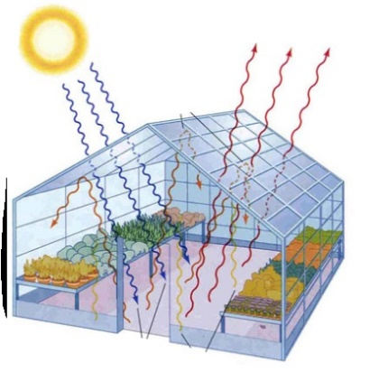 A student investigated the effect of the concentration of carbon dioxide on the temperature produced in a glass greenhouse. He used a garden greenhouse and measured the initial concentration of CO2 and the temperature. Each morning, he increased the concentration of CO2 (using bottled carbon dioxide) then recorded the temperature within the greenhouse at 4pm.

1. Write a hypothesis for this student’s investigation.

(2 marks)

* Relate temperature in greenhouse and carbon dioxide concentration
* Explicit testable 3rd person statement
* E.g. The higher the concentration of CO2 in the greenhouse the higher the temperature within the greenhouse

1. Identify the dependent variable in this investigation.

(1 mark)

Temperature within the greenhouse

1. Identify the independent variable in this investigation.

(1 mark)

Concentration of carbon dioxide gas added to greenhouse

1. State **two** variables that the student controlled in his investigation.

(2 marks)

* Time of day temperature was measured
* Volume/size of the greenhouse
* Colour/type of greenhouse glass

The following data was collected by the student.

|  |  |  |  |  |  |  |  |  |
| --- | --- | --- | --- | --- | --- | --- | --- | --- |
| Concentration of CO2  (mg/L) | 10 | 15 | 20 | 30 | 40 | 50 | 65 | 80 |
| Temperature inside the greenhouse  (oC) | 25 | 31 | 36 | 43 | 48 | 49 | 54 | 55 |

1. Draw an appropriate graph of this data with a line (curve) of best fit.

(6 marks)

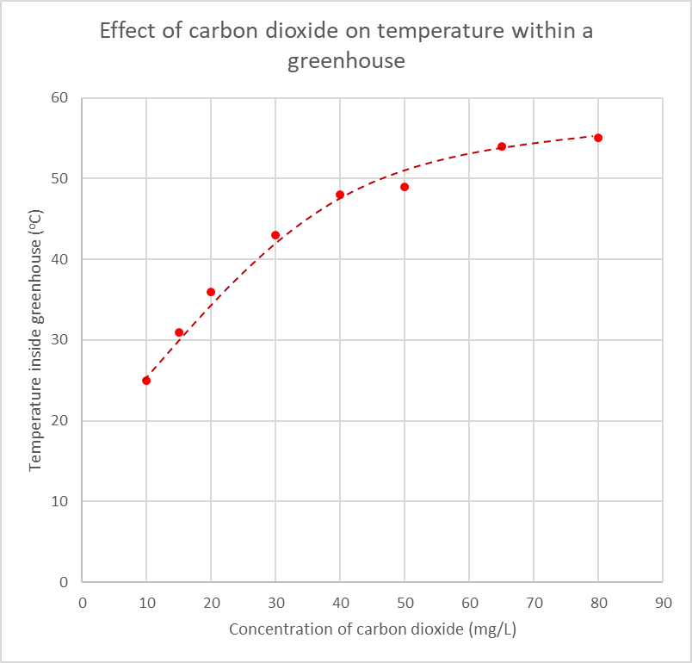

Minus 1 mark for each wrong/missing (max 6)

* Appropriate title
* Correctly labelled axes / Units on axes
* Independent variable on horizontal axis
* Appropriate scale
* Correctly plotted points
* Smooth curve of best fit

1. Describe the relationship between the independent and dependent variables of this experiment. Be specific by referring to data from your graph.

(2 marks)

If student writes something to effect of:

* The temperature in the greenhouse increases as the concentration of CO2 increases – 1 mark
* The temperature in the greenhouse increases at a decreasing rate as the concentration of CO2 increases – 2 marks

Note that the students haven’t been taught “increasing at a decreasing rate” in maths. Accept terms similar to this:

“as the temperature rose, larger increases in CO2 concentration were required to increase the temperature of the greenhouse further”

“initially the temperature increases a lot but as more CO2 is added, the temperature of the greenhouse rises less and less”

“the temperature rose until a point when it stopped increasing as much as CO2 was added, resulting in the points getting closer together as if it has reached a temperature limit”

1. Does the description you wrote for question 6 support or not support the hypothesis you wrote in question 1? Circle your choice below and explain your reasoning.

(1 mark)

Support / Does Not Support

Will depend on student’s previous answers –

To get mark students’ justification for support/refute must relate to hypothesis in Question 1 and the relationship shown in the graph

1. The students’ teacher told him that the investigation was not **valid (a fair test)**.
   1. What is a **fair test**?

(1 mark)

* Adequately tests the required variable whilst controlling all other variables likely to affect the outcome of the investigation
  1. State **one** major error in the student’s investigation and explain **why** it makes the investigation invalid. (2 marks)

1 mark - stating major error

1 mark - explaining why investigation invalid

* Give followthrough for the 2nd mark if they explain how their chosen flaw means the test is invalid

Either:

* External temperature not taken into account (hot day vs cold day) therefore the temperature within greenhouse could therefore be a result of outside temperature influences

Or:

* Same amount of sunlight can not be guaranteed (cloud cover, rain etc) thus the temperature within the greenhouse could be compromised.
  1. Suggest **one** way the student could alter the investigation to overcome the major error you outlined in 8band **how** it overcomes the error.

(2 marks)

1 mark – relevant suggestion

1 mark – explains how it overcomes flaw

Students’ answers need to be explicit and detailed.

Give follow-through marks if the suggestion is reasonable, addresses the error and is explained clearly (even if the error isn’t correct).

For example:

* Rather than use a greenhouse, student could simulate the investigation within laboratory conditions using a container of known volume and a heat lamp. This ensures the conditions are kept the same.
* Student could record the external temperature and compare change in temperature between inside and outside of greenhouse to the concentration of CO2. This accounts for temperature differences each day.
* Use a control. One greenhouse next to the other greenhouse that has no CO2 added to it. This would then prove whether or not the CO2 is the variable influencing the temperature within the greenhouse.